Computing Systems – Computing Pioneers, and Using Wikipedia

20th Century Pioneers
For the following computing pioneers, you are asked to answer the following questions:
- What computing invention(s) were they involved in?
- What was the significance of this?
- How did this work influence the development of the computing field at the time? And in the following decades?
- What is the lasting impact of each pioneer’s work?
There are a number of websites that you might choose to use for this research, including but not limited to:
- Wikipedia – everyone’s first destination. But it shouldn’t be your only one!
- Computer History Museum – http://www.computerhistory.org , based in Silicon Valley. They also have a very large archive of old films and more recent lectures and talks on YouTube: http://www.youtube.com/user/ComputerHistory
- Some of the individuals you have to research also have sites dedicated to them or to their projects. Some are listed below, some you may need to find for yourself.

Alan Turing
Also see: http://www.turing.org.uk/ , http://www.bbc.co.uk/history/people/alan_turing
Invention(s) (Machines, ideas, designs, concepts, etc) | Turing Machine it manipulated symbols on a strip of tape according to a table of rules.
Significance? | He decoded the enigma code along with thousands of other German army messages and was probably solely responsible for the allied victory
Influence? At time of invention? In following decades? | The church Turing thesis influenced the basic structure of computing at the time that it was thought of and future computing.
Lasting impact? | If Alan and his team of decoders did not crack the enigma code them the Germans may have succeeded in winning the war.

Konrad Zuse
Also see: http://www.zib.de/zuse/home.php
Invention(s) (Machines, ideas, designs, concepts, etc)

Significance?

Influence? At time of invention? In following decades?

Lasting impact?

John von Neumann
Do make sure you read up on the background to the First Draft Report on the EDVAC: and von Neuman’s role in developing EDVAC – not all is as it first seems.
Invention(s) (Machines, ideas, designs, concepts, etc)

Significance?

Influence? At time of invention? In following decades?

Lasting impact?

Grace Hopper
Http://www.gracehopper.org/ is the home for a program that aims to improve recognition and opportunities for women in computing – but also has an area with biographical information about Grace Hopper.
Invention(s) (Machines, ideas, designs, concepts, etc)
Significance?

Influence? At time of invention? In following decades?
Lasting impact?

Douglas Engelbart
http://sloan.stanford.edu/mousesite/ is a site dedicated to some of Doug Engelbart’s most famous work – including a 90 minute video of a demo his group led in 1968 (in archive section). His current and historical work is also detailed at the Doug Engelbart Institute: http://dougengelbart.org/
Invention(s) (Machines, ideas, designs, concepts, etc)
Significance?

Influence? At time of invention? In following decades?
Lasting impact?

Using Internet Resources
Review the Wikipedia page on Grace Hopper, and her biography at gracehopper.org. Then review the mentions of Grace Hopper in the ‘How Computers Work’ book (pages 82, 85, 196). Then try to answer the following.

- What is the origin of the term ‘bug’ to refer to an error in a computer program?

- In relating the origin of the term computer ‘bug’, what differences are there between accounts in the text book and the online resources?

Well written Wikipedia articles always include references to original or authoritative sources. From the anecdote section of the article, find and follow the link to view the entry on the ‘Log book with Computer Bug’ at the National Museum of American History.
- Why is it important to be able to check the source of information in a Wikipedia article?

From the top of the Wikipedia article on Grace Hopper, there is a link to a ‘Talk’ page. Click on that link and review the sections ‘bug’ and ‘Earliest reference for Hopper’s bug’.
- What is the purpose of a ‘Talk’ page on Wikipedia?

- According to a story from one of the links on the talk page, what chain of events resulted in the Log Book ending up at the Smithsonian National Museum of American History?

It is also possible to review the history of a page in Wikipedia – by selecting the ‘view history’ link from the top of any article. Note that talk pages have their own separate history.
- Return to the main article and click on ‘View History’
- Clicking on a date allows you to see the version of the article from that date. Note that you can also see who made each edit (or their IP address)
- By using the round radio buttons, you can select two different versions of the article to compare – clicking on the ‘Compare selected revisions’ buttons will allow you to see the differences between any two versions of the article.
At the bottom of the history page, click in ‘earliest’ to see a list of the very earliest versions of the article: http://en.wikipedia.org/w/index.php?title=Grace_Hopper&dir=prev&action=history
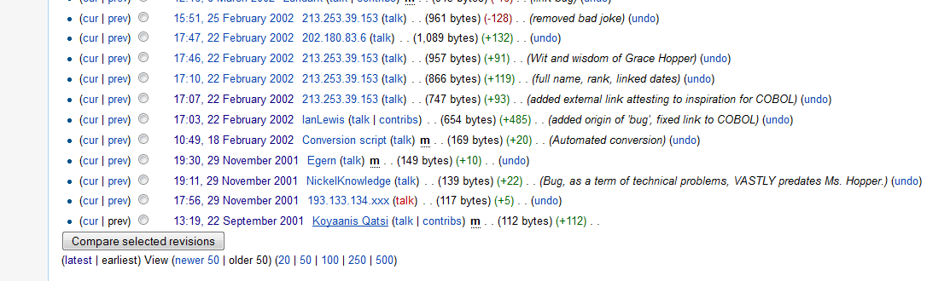
- Open the very first version of the Wikipedia article from 22nd September 2001: http://en.wikipedia.org/w/index.php?title=Grace_Hopper&oldid=254839
- Click on the ‘Newer Revision’ link. Do this about five time – until you get to the first version of the article with any significant amount of content. How much of this version remains today? How much has been added.
From these exercises, you should understand that Wikipedia articles can have very many authors. Ideally, over time this will result in well researched and accurate articles – but authors may, and sometimes do, put in incorrect information or may actively try to vandalise articles. You should form a habit of checking out the sources of an article, and to not automatically trust everything. History of articles provides another way to review the content.
Unlike a traditional text-book, if you see an error in a Wikipedia article, or an article that needs more detail, you can edit it yourself. Sometimes articles are flagged as needing improvement. For example, at the time of writing, the article on the ‘Instruction cycle’ is flagged as being of poor quality and in need of improvement.

